www.arkansaslivinghistory.com

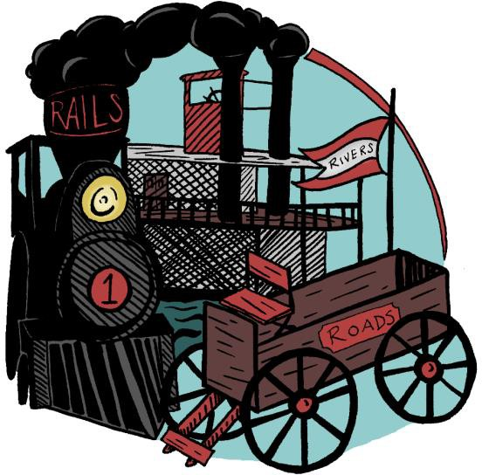
2023 Conference
Transporting Living History to New Destinations
February 10 – 12, 2023
Paragould Community Center, Paragould, Arkansas
Hosted by The Northeast District of ALHA and Arkansas State Parks

Call for Workshops, Sessions, Panels, and Presentations

Transportation played a crucial role in developing the Arkansas we know and interpret as Living Historians today. These tangibles and intangibles that link one place to another also serve as a reminder to reflect on how we as an institution connect our resources to the visiting public. Are the systems we have in place creating a smooth and enjoyable experience for the visitor? How has/did your site navigated the hazards of COVID-19 and what new and novel ideas are you exploring in this time of uncertainty and change?
The Arkansas Living History Association seeks proposals for online workshops, sessions, panels, and presentations for the 2023 Conference. To submit a proposal, please fill out the form on the back. Attach additional sheets if necessary. Submissions will be accepted by mail or email. All presenters are expected to register for the full meeting or the day on which they present
Deadline for Submissions is November 4th, 2022
Title of Session: ________________________________________________
Proposals can be submitted via email or paper to the addresses below.
Aaron Loehndorf
118 West Johnson Ave
Springdale, AR 72764
aloehndorf@springdalear.gov

Title of Session: Description: (overview of content, goals, application)

Format: (circle/highlight one): Session Conference Workshop Panel/roundtable discussion Performance/Demo Other
Length: (please circle/highlight one): 50 min 3 hour workshop 6 hour workshop
Workshop Cost Per Person: Indoor or Outdoor: Fire required for workshop: Y N
A/V Needs: Will You Be Using a PowerPoint? Y N
Special/ Additional Needs:

Session Leader Information:
Name: Affiliation: Address: Email Address: Phone Number:
Additional Presenters: (Please provide same information as session leader for each additional participant):

_

