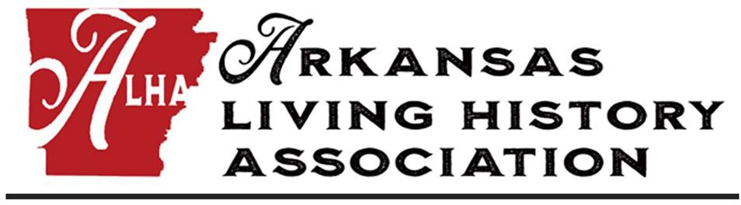

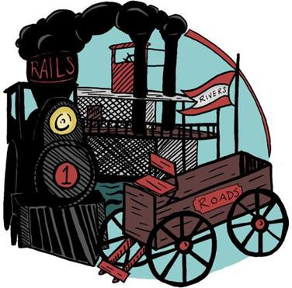

Transporting Living History to New Destinations
February 10 – 12, 2023 Paragould Community Center Paragould, Arkansas
Hosted by
Arkansas Department of Parks, Heritage and Tourism

Conference Supporters

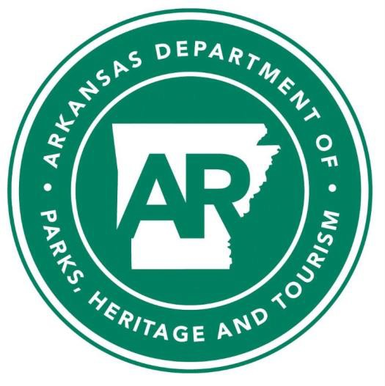
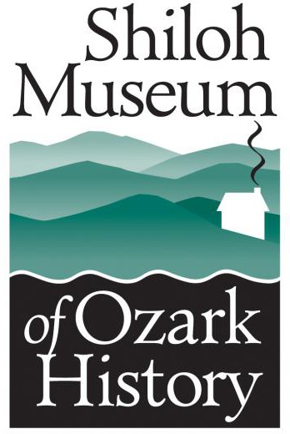

Keynote Speaker: Peter Friesen
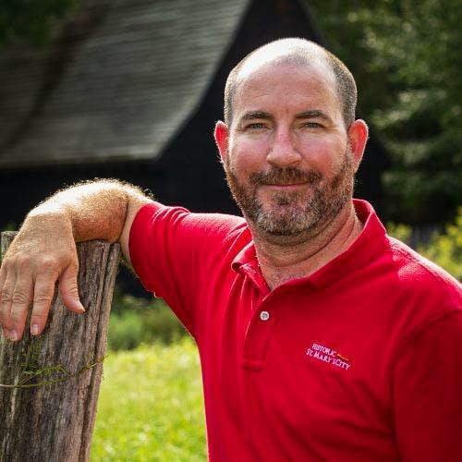
Peter Friesen is the Director of Education at Historic St. Mary's City in St. Mary's City, Maryland.

He has a Bachelor's and Masters' from New Mexico State University. During his senior year at NMSU Peter decided to focus on a career in living history. He took an internship at Valley Forge National Historic Park. After graduating, Peter decided to attend graduate school and focus on public history. While there he took part in a class called Time Traveling where he learned about first person interpretation. His degree plan included a research paper. His research paper titled Hemp, History and Museums, looked at how marijuana laws have affected public perception of hemp and how it is interpreted in living history museums. This led Peter to Colonial Williamsburg where he worked for two years finishing his research and completing a master’s degree. During this time, he started to look for a living history museum that also incorporated agriculture, which is how he came to be at HSMC. After his first year at HSMC, he received the New Professional Travel Award for the National Council of Public History’s annual conference in Louisville, KY where he presented his research on Hemp and Museums. Peter has continued his agricultural research to include tobacco, apples, livestock, and other aspects colonial farming life. He also serves on the museum studies steering committee at St. Mary’s College of Maryland as well as teaching museums studies.

This project is supported in part by a grant from the Arkansas Humanities Council and the National Endowment for the Humanities.

Session and workshop location:
Paragould Community Center 3404 Linwood Drive
Paragould, AR 72450 https://www.cityofparagould.com/312/Community-Center

Lodging and Transportation

Lodging Information
Hampton Inn Paragould 3810 Linwood Drive
Paragould, AR 72450
(870) 565-1010

$99 a night with breakfast, parking and Wi-Fi included. Reservations can be made online or by calling the hotel.

https://www.hilton.com/en/hotels/pgrfdhx-hampton- paragould/?SEO_id=GMB-AMER-HX- PGRFDHX&y_source=1_MzgxMDkwNi03MTUtbG9jYXRpb24ud2 Vic2l0ZQ%3D%3D
Reservation must be made by January 19th, 2023

Transportation

Carpooling is encouraged for sessions, and the field trip to Powhatan State park.

Direction to Powhatan State Park from Paragould Community Center:

- Turn right onto Linwood Drive (heading south).
- Turn right onto Business 412.
- Turn left onto U.S. Highway 412 West.
- Stay on 412 when it merges with Highway 63.
- Turn right onto 3rd Street towards Highway 25, following signs for Powhatan Courthouse.
- Turn right onto Highway 25.
- Following Highway 25 to Powhatan State Park.

Auction Information
Help support the ALHA fellowship program with your donation to the annual auction! We will feature both our traditional silent auction and a live auction. This is a great opportunity to promote your business or site, find new homes for old living history gear, or just make some room on your bookshelf at home. You can drop your item off at the conference registration table and all donations are tax deductible.

CASH OR CHECK ONLY FOR AUCTION PAYMENTS

Have more questions about your region? Contact your district representative.

District 1: Currently open

District 2: Daniel Cockrell, Old State House Museum Daniel.Cockrell@arkansas.gov

District 3: David Fowler, Hunter's Home
Dfowler@okhistory.org

District 4: Holly Ballard, Historic Washington State Park holly.ballard@arkansas.gov
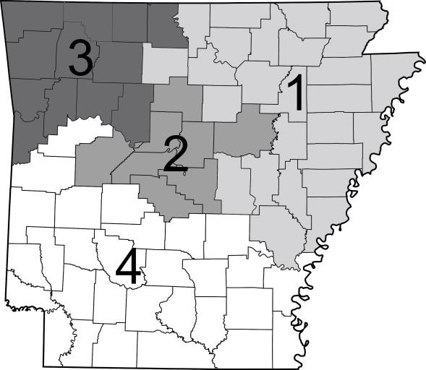

Apprentice, Journeyman, and Master Certifications
The Arkansas Living History Association encourages high standards for living history performances. The ALHA certification process was designed to recognize members’ efforts and to assist educators, parks and museum staff, living history event sponsors, and others in identifying quality living historians that are historically/factually accurate and skilled in public performance designed to educate the public.

Interested persons can visit the ALHA website to download requirements for the certification process: https://arkansaslivinghistory.com/Downloads.
Anyone wanting to begin or continue the process may sign up for the certification training workshops held on Friday, February 10. See the Workshops page on the website. Any member of the Arkansas Living History Association who desires to be certified as a journeyman level in a first or third-person living history performance will submit an application packet as posted on the website. Master and Journeyman presentations will take place Friday, February 10, from 5:30–8:30 p.m.

For more information, or to sign up for the Journeyman and Master certification, contact Josh Williams: josh.williams@arkansas.gov.

Conference at a Glance

Friday, February 10

8:00 a.m.

9:00 a.m.–4:00 p.m.
1:00–4:00 p.m.
5:30–8:30 p.m.

9:00 p.m.
Saturday, February 11

8:00 a.m.

8:30–11:20 a.m.

11:30–12:30 p.m.

1:30–4:00 p.m.

6:00–6:30 p.m.

6:30-7:30 p.m.

7:30–9:00 p.m.

Following Auction
Sunday, February 12

8:30 a.m.

9:00–10:50 a.m.
Paragould Community Center

Registration

All Day Workshops
Afternoon Half Day Workshops
Opening Reception & Performances for ALHA Certification
Hospitality Room
Paragould Community Center

Registration Table & Silent Auction Item Drop off

Concurrent Sessions

Lunch and Business Meeting

Field Trip – Powhatan State Park
Silent Auction Preview and District Meetings
Dinner and Keynote Live Auction Hospitality Room
Paragould Community Center

Registration Concurrent Sessions

Friday, February 10

Workshops
Workshops will be held at Paragould Community Center. Lunch is included for the Apprentice Workshop.

All Day
9:00 a.m.–4:00 p.m.

Apprentice Workshop (Lunch Included)
Cost: $10
Full-day workshops covering the basics of Living History 101: creating a character, basic performance skills, research, dealing with special problems in living history, event planning basics, and other topics. Certification guidelines can be downloaded from the Arkansas Living History Association Website.
ALHA Certification Board

Half Day Afternoon 1:00–4:00 p.m.

The Victorian Art of Hairwork
Cost: $10 Limit: 10
Brief history of hair work, set-up and tutorial, crafting individual hair work pieces, creation of final product, discussion and questions.
Amy Armstrong, Living History Coordinator, Historic Arkansas Museum, Morgan Weithman, Education Program Assistant, Historic Arkansas Museum

Brewing on a Small Scale
Cost: $20 Limit: 8
Brewing was a useful skill for both house and tavern keepers alike during the first half of the 19th century. The "Beers" of the time provided everything from crisp refreshment to meal-like sustenance to yeast for baking. We'll explore period recipes, ingredients, and techniques while learning how to make our own beer on a scale fit for any site.
Ian Beard, Education Director, Historic Arkansas Museum

Friday Evening Events

Opening Potluck and Reception ALHA Journeyman Certification Review 5:30–8:30 p.m.
ALHA members wishing to complete their Journeyman certification must stand for the review panel. You must have already received your Apprenticeship certification, notified the committee, and completed all other requirements for Journeyman certification. All ALHA members are invited to observe the review process.
Conference attendees are invited to bring a historic delicacy to share during the potluck meal.

Conference Hospitality Space 9:00 p.m.
Enjoy informal networking, camaraderie, and late night refreshment at the host site.

Saturday, February 11

Registration & Silent Auction Item Drop Off 8:00 a.m.

Concurrent Session I 8:30–9:20 a.m.

Early Steamboats of Arkansas
This program will cover the importance of steamboats to Arkansas growth and settlement.
Richard Spilman, Education Coordinator, Delta Cultural Center

Introduction to Blacksmithing – Limit of 20
Come swing a hammer and learn the basics to 19th century blacksmith shop. We will cover the different parts of the anvil, the tools of the trade, and some simple hammer techniques. While in the comfort of a classroom, participants will get the opportunity to "forge" on their own.
Casey Marshall, Museum Programs Specialist, Historic Arkansas Museum

Concurrent Session II 9:30–10:20 a.m.

Railroads
Delta Heritage Trail State Park is a story of transportation. Under development, primarily as a Rail-to-Trails project, telling the story of how the establishment of the rail line served as a transportation artery that spurred economic development across the landscape it connected is a goal of the park. This session will showcase how we connect visitors to this railroad legacy from interpretive programs and exhibits, gift shop resale, and outreach. A secondary goal is to demonstrate how railroad development impacted all of Arkansas and how this story can be integrated at other public history sites.
Ryan Smith, Park Interpreter, Delta Heritage Trail State Park

Recreating a Funeral
Learn about the research and steps it took to recreate a funeral that took place in 1866 Washington, Arkansas. Hear the unique story of the funeral of Jennie Vann.
Josh Williams, Curator, Historic Washington State Park, Chris Adams, Park Historian, Historic Washington State Park

Concurrent Session III 10:30–11:20 a.m.

Amplifying Voices
This round table discussion of examples of community partnerships will provide participants a chance for active conversation about the strengths of partnering and creative solutions to find new and unconventional partners from our communities.
Daniel Cockrell, Director, Old State House Museum

Saturday Lunch and Business Meeting 11:30–12:30 p.m.

Field Trip 1:30–4:00 p.m.

Field trip: Powhatan State Park

Direction to Powhatan State Park from Community Center:

- Turn right onto Linwood Drive (heading south).
- Turn right onto Business 412.
- Turn left onto U.S. Highway 412 West.
- Stay on 412 when it merges with Highway 63.
- Turn right onto 3rd Street towards Highway 25, following signs for Powhatan Courthouse.
- Turn right onto Highway 25.
- Following Highway 25 to Powhatan State Park.

Saturday Evening Events
All events will take place at the Paragould Community Center. Dressing in your favorite living history outfit is encouraged.

Silent Auction Preview and District Meetings 6:00–6:30 p.m.

Dinner and Keynote 6:30-7:30 p.m.

Keynote Address
Peter Friesen, Director of Education, Historic St. Mary's City

Live Auction 7:30–9:00 p.m.

Conference Hospitality Room
10:00 p.m.

Enjoy informal networking, camaraderie, and late night refreshment at the host site.

Sunday, February 12

Session IV 9:00–9:50 a.m.

A Blind Guy Walks Into a Museum
In this program we will discuss the ways one can adapt programming to accommodate people with disabilities. We will look at accommodating adaptive technology while not limiting access to programming for other visitors. We will also discuss the advantages of having an accommodation plan in place and how accommodations might also be useful to members of the general public
Leon Tidwell, Education Coordinator, Historic Arkansas Museum

Session V

Un-varnishing History: How Historic St. Mary's City is Evolving to Create Engaging Programs and Exhibits Without the Whitewash
Historic St. Mary's City is nearing the four hundredth anniversary of the founding of Maryland. This fast-approaching landmark date offers an opportunity for HSMC to grow beyond our original Anglo- centric mission and to tell an inclusive unfiltered version of history that does not just glorify it, but chooses to examine it critically. Over the last five years, Historic St. Mary's City has begun the process of changing the narrative of the stories interpreted at our museum from beyond the standard “great white fathers” narrative to a more diverse collection of stories about all the people, from three diff- erent continents, who converged on this landscape in the 17th century. From programs for school groups to the award winning “Sin and Scandal”, and “Adults-Only” Tour, we have developed programs for all demographics. This presentation will illustrate the process we have experienced and are experiencing while working with various underrepresented groups with a great variety of successes and missteps.
Peter Friesen, Director of Education, Historic St. Mary's City

2023 Conference Committee: Jeannine Thompson, Daniel Cockrell, Kim Hosey, Aaron Loehndorf
Have a Safe Trip Home! 2024 ALHA Conference
Historic Washington, Arkansas

TBD, 2024

2022 ALHA Budget

Total Income

Grants Auction Conference
Membership Dues

Total Expenses
ALHA Fellowships ALHFAM Fellowships Operations
Paypal & Bank Charges Conference

Arkansas Living History Association
PO Box 648
Little Rock, AR 72203
www.arkansaslivinghistory.com

